

SIES GRADUATE SCHOOL OF TECHNOLOGY, NERUL

Certificate

|  |  |
| --- | --- |
| This is to certify that, |  |
| Name of the Student | PRN No |
| MOHAMMED YASIN | 116A3004 |
| PRANAV ASHTAPUTRE | 116A3007 |
|  |  |

Have submitted the Internet Programing Project **“SOLIDUOUS SYSTEMWARE”** as per the requirement of the syllabus of the **DEGREE (INFORMATION TECHNOLOGY)** course, according to the rules laid down by the **DTE**, during the academic year 2018-2019 in view of fulfilment of the degree in Information Technology.

Date: 24th October 2018

**(Prof. VIJAY KATKAR)**

**Guide & Project Co-ordiator**

**( Prof. K . LAKHSMISUDHA) (Dr. VIKRAM PATIL)**

**Headof Department Principal**

**AIM**

A “SOLIDUOUS SYSTEMWARE” name website , designed for a private shop holder that sells and repair the hardware as well as software products.

Previously, the owner did not have an online access to sell any of his product.

We provide both product and service. Our website aims at providing the services online which will make the process easier for the user as well as for the management of the shop owner.

**INTRODUCTION**

This “SOLIDUOUS SYSTEMWARE” website is aimed at increasing the contact between the user and the management. This is a web based application to provide ecommerce facility as well as repairing hardware products. The user can order the products and also can complain to the management if any default. This is very useful for the people near and around in mumbai to buy hardware products as well as for hiring a better employee for any damage part of any hardware devices.

**ABSTRACT**

Previously, the owner just used to repair the hardware product. The owner used to get an appointment by just a phone call. He had to schedule a proper timing for different complaints and also complete the work in proper fixed time else would have created a problem between the customer and the the owner.

The basis of this project is to create a website for the owner who sells and repair hardware product . The software and technique we used to create this website: Laravel(Php framework) , MySql, Xampp Server, HTML, CSS, PHP,JS and Chrome browser for testing purpose. This website is responsive therefore it can be accessed in any device.

**PROPOSED SYSTEM**

In Laravel (Php framework) we have implemented an online website for a trust . It has an online register form which will be filled by the user or applicants seeking to buy or repair any hardware product. After the form has been submitted, the admin will verify it manually . This applicant thereafter can place an order or register a complaint in terms of feedback. After the verification has been done , the admin will get the database of the registered user who can buy the product. The applicant can see the status of their order i.e either the the product is on process or still in hault . If rejected the reason will also be mailed to the registered user. The record will be saved in the database .

**EXISTING SYSTEM**

The existing system did not consist of any online service for buying hardware products. Also the owner used to get the calls for any repairing work. The owner used to maintain the offline records for the complains or the ones who used to buy the products from him. Whenever he used to get a repair work he used to go to their house and used to solve the problem.

**MODULES :-**

It is mainly consists of Five modules like,

1. Homepage
2. Customer Details form
3. Order
4. About Us
5. Logout
   * + **Homepage:** It consists of the whole description of the website.Here different facilities are displayed as well the owners info and address.
     + **Application form:** It provides the details of the applicant to the administrator including the purpose of the financial need.
     + **Order:** After getting login by the user, he/she will be directed to the order website where he can order the products.
     + **About us:** Here the admin contact information will be provided like the admin email id, phone number, facebook, twitter id etc. for any assistance user can contact to the admin. The location of the centre is also provided here which can help users to reach to us.

**RESPONSIVE WEB DESIGN FRAMEWORK**

**What is a framework?**

A frame work is *a standardized set of concepts,practices and criteria for dealing with a common type of problem*, which can be used as a reference to help us approach and resolve new problems of a similarnature.

In the world of web design, to give a more straightforward definition, a framework is defined as a *package made up of a structure of files and folders of standardized code(HTML,CSS,JSdocuments etc.)* which can be used to support the development of websites, as a basis to start building asite.

Most websites share a very similar (not to say identical) structure. The aim of frameworks is to provide a common structure so that developers don’t have to redo it from scratch and can reuse the code provided. In this way, frameworks allow us to cut out much of the work and save a lot of time.

**Bootstrap**

BootstrapisanopensourcetoolkitfordevelopingwithHTML,CSS,andJS.Quicklyprototypeyour ideas or build your entire app with our Sass variables and mixins, responsive grid system, extensive prebuilt components, and powerful plugins built onjQuery.

# TYPES OF CSS

### CSS comes in three types:

* In a separate file (**external**)
* At the top of a web page document(**internal**)
* Right next to the text it decorates(**inline**)

**External** style sheets are separate files full of CSS instructions (with the file extension .css). When any web page includes an external stylesheet, its look and feel will be controlled by this CSS file (unless you decide to override a style using one of these next two types). This is how you change a whole website at once. And that's perfect if you want to keep up with the latest fashion in web pages without rewriting every page!

**Internal** styles are placed at the top of each web page document, before any of the content is listed. This is the next best thing to external, because they're easy to find, yet allow you to 'override' an external style sheet -- for that special page that wants to be a nonconformist!

**Inline** styles are placed right where you need them, next to the text or graphic you wish to decorate. You can insert inline styles anywhere in the middle of your HTML code, giving you real freedom to specify each web page element.On the other hand,this can make maintaining web pages a real chore

**CSS CODE**

**RESPONSIVE DESIGN CODE**

Login Page

<html>

<head>

<title>form1</title>

<meta charset="UTF-8">

<meta name="viewport" content="width=device-width, initial-scale=1.0">

<link rel="stylesheet" href="https://stackpath.bootstrapcdn.com/bootstrap/4.1.3/css/bootstrap.min.css">

<script src="https://code.jquery.com/jquery-3.3.1.slim.min.js"></script>

<script src="https://stackpath.bootstrapcdn.com/bootstrap/4.1.3/js/bootstrap.min.js"></script>

<style>

body {

margin: 0;

font-family: Arial, Helvetica, sans-serif;

}

.topnav {

overflow: hidden;

background-color: #333;

}

.topnav a {

float: left;

color: #f2f2f2;

text-align: center;

padding: 14px 16px;

text-decoration: none;

font-size: 17px;

}

.topnav a:hover {

background-color: #ddd;

color: black;

}

.topnav a.active {

background-color: #4CAF50;

color: white;

}

.topnav b {

float: right;

display: block;

color: white;

text-align: right;

padding: 14px 16px;

text-decoration: none;

font-size: 34px;

}

.topnav b:hover {

background-color: #ddd;

color: black;

}

body{

background-image: url("img1.jpeg");

color: white;

}

input.transparent-input{

background-color:rgba(0,0,0,0) ;

color: white;

}

th, td {

padding: 15px;

}

@media (max-width: 600px) {

.col1, .col2 {width:100%;

font-size:1.8rem;}

}

@media screen and (min-width:900px){

body{

font-size:1.6rem;

center:50%

}

}

.col1{

float:left;

width:25%;

margin-top:8px;

}

.col2{

float:left;

}

.footer {

position: fixed;

left: 0;

bottom: 0;

width: 100%;

background-color:black;

color: white;

text-align: center;

height: 25px;

font-size: 18px;

}

</style>

<script type='text/javascript'>

function validation()

{

if (document.login.email.value == "")

{

alert("Email should not be empty")

return false;

}

if (!/^([a-zA-Z0-9_\.\-])+\@(([a-zA-Z0-9\-])+\.)+([a-zA-Z0-9]{2,4})+$/.test(document.login.email.value))

{

alert("Enter valid email address")

return false;

}

if (document.login.pwd.value == "")

{

alert("Password should not be empty")

return false;

}

return true;

}

</script>

</head>

<body style="background-image:url('img1.jpeg')">

<center>

<h1 font-size:5vw; font-family:courier; text-align:center">SOLIDUOUS SYSTEMWARE </h1>

<div class="topnav">

<a class="active" href="homepage.html">Home</a>

<a href="http://localhost/miniproject/ajax.php">Service Centres</a>

<a href="http://localhost/miniproject/form2.html">Feedback</a>

<a href="http://localhost/miniproject/aboutus.php">About Us</a>

<?php

session_start();

if (!isset($_SESSION['email'])) {

?>

<a href="form1.html">Login</a>

<a href="customer.html">Registration</a>

<?php } else {

?>

<a href="cdetails.php" style='color:red'><?php echo $_SESSION['email'] ?></a>

<a href='logout.php'>Logout</a>

<?php } ?>

</div>

<h1 style="font-size:10vw">Login</h1>

<form name='login' class="form-horizontal" method="POST" >

<table >

<tr >

<th class="col1" >Email </th> <th class="col2" > <input type="text"

placeholder="Enter Email" class="form-control transparent-input" name="email" id="email"> </th>

</tr>

<tr >

<th class="col1" >Password </th> <th class="col2" ><input type="password"

placeholder="Enter password" class="form-control transparent-input" name="pwd" id="pwd"> </th>

</tr>

<tr >

<th class="col2"><button type="submit" class="btn btn-success" name="submit"

onclick="return validation()" formaction="login.php" >Submit</button> </th>

<th class="col2"><button class="btn btn-danger" formaction="alogin.php">Login as Admin</button> </th>

</tr>

<tr >

<th class="col2"><button class="btn btn-success" formaction="customer.html">Register</button> </th>

<th class="col2"><button class="btn btn-success" formaction="forgotpwd.html">Forgot Password?</button> </th>

</tr>

</table>

<footer style="text-align: center; padding: 5px">

<p>

© 2018 Soliduous Systemware. All rights reserved.

</p>

</footer>

</form>

</center>

</body>

</html>

Home Page

<!DOCTYPE HTML>

<html>

<head>

<title>homepage</title>

<meta charset="UTF-8">

<meta name="viewport" content="width=device-width, initial-scale=1.0">

<link rel="stylesheet" href="https://maxcdn.bootstrapcdn.com/bootstrap/4.1.3/css/bootstrap.min.css">

<script src="https://ajax.googleapis.com/ajax/libs/jquery/3.3.1/jquery.min.js"></script>

<script src="https://cdnjs.cloudflare.com/ajax/libs/popper.js/1.14.3/umd/popper.min.js"></script>

<script src="https://maxcdn.bootstrapcdn.com/bootstrap/4.1.3/js/bootstrap.min.js"></script>

<style>

body {

margin: 0;

font-family: Arial, Helvetica, sans-serif;

}

.carousel-inner img {

width: 100%;

height: 100%;

}

.topnav {

overflow: hidden;

background-color: #333;

}

.item img {

position: absolute;

top: 0;

left: 0;

min-height: 300px;

}

.bg-image {

/* Full height */

height: 100%;

/* Center and scale the image nicely */

background-position: center;

background-repeat: no-repeat;

}

/* Images used */

.img1 {

background-image: url("img5.jpg");

}

.topnav a {

float: left;

color: #f2f2f2;

text-align: center;

padding: 14px 16px;

text-decoration: none;

font-size: 17px;

}

.topnav a:hover {

background-color: #ddd;

color: black;

}

.topnav a.active {

background-color: #4CAF50;

color: white;

}

.topnav b {

float: right;

display: block;

color: white;

text-align: right;

padding: 14px 16px;

text-decoration: none;

font-size: 34px;

}

.topnav b:hover {

background-color: #ddd;

color: black;

}

th, td {

padding: 15px;

}

.container{

color: white;

}

@media (max-width: 600px) {

.col1, .col2 {width:100%;

font-size:1.8rem;}

}

@media screen and (min-width:900px){

body{

font-size:1.6rem;

center:50%

}

}

.col1{

float:left;

width:5%

}

.col2{

float:left;

}

iframe {

width: 350px;

height: 350px;

}

footer {

left: 0;

bottom: 0;

width: 100%;

background-color:black;

color: white;

text-align: center;

height: 35px;

font-size: 20px;

}

</style>

</head>

<body style="background-image:url('testing.png')">

<center>

<h1 style="background-color:#f2f2f2; font-size:5vw; font-family:courier; text-align:center">SOLIDUOUS SYSTEMWARE</h1>

<div class="topnav">

<a class="active" href="homepage.php">Home</a>

<a href="http://localhost/miniproject/ajax.php">Service Centres</a>

<a href="http://localhost/miniproject/form2.html">Feedback</a>

<a href="http://localhost/miniproject/aboutus.php">About Us</a>

<?php

session_start();

if (!isset($_SESSION['email'])) {

?>

<a href="form1.html">Login</a>

<a href="customer.html">Registration</a>

<?php } else {

if ($_SESSION['email'] === "admin"){

?>

<a href='custdetails.php'>Customer Details</a>

<a href='product.php'>Product Details</a>

<a href="orders.php">Orders</a>

<a href="vfeedback.php">View Feedback</a>

<a style='color:red'><?php echo $_SESSION['email'] ?></a>

<a href="logout.php">Logout</a>

<?php } else {?>

<a href="purchase.php">Purchase</a>

<a style='color:red'><?php echo $_SESSION['email'] ?></a>

<a href="logout.php">Logout</a>

<?php } }?>

</div>

<div id="demo" class="carousel slide" data-ride="carousel">

<!-- Indicators -->

<ul class="carousel-indicators">

<li data-target="#demo" data-slide-to="0" class="active"></li>

<li data-target="#demo" data-slide-to="1"></li>

<li data-target="#demo" data-slide-to="2"></li>

<a href="homepage.php"></a>

</ul>

<!-- The slideshow -->

<div class="carousel-inner">

<div class="carousel-item active">

<img src="img0.jpg" alt="Los Angeles" width="1100" height="500">

</div>

<div class="carousel-item">

<img src="img2.jpg" alt="Chicago" width="1100" height="500">

</div>

<div class="carousel-item">

<img src="img3.png" alt="New York" width="1100" height="500">

</div>

</div>

<!-- Left and right controls -->

<a class="carousel-control-prev" href="#demo" data-slide="prev">

<span class="carousel-control-prev-icon"></span>

</a>

<a class="carousel-control-next" href="#demo" data-slide="next">

<span class="carousel-control-next-icon"></span>

</a>

</div>

<div class="bg-image img1">

<div class="maincont">

<div class="container" style=" width: 320px; height: 320px">

<iframe src="https://www.google.com/maps/embed?pb=!1m18!1m12!1m3!1d3773.772464575235!2d72.82144071445997!3d18.94146296111077!2m3!1f0!2f0!3f0!3m2!1i1024!2i768!4f13.1!3m3!1m2!1s0x3be7d1e1dcfe5f1d%3A0x2ddc00e19af3ee69!2sMarine+Drive!5e0!3m2!1sen!2sin!4v1540278895017" width="300" height="280" frameborder="1" style="border:2px solid #F66468"></iframe>

</div>

<div class="container">

<br><br>

<h1> SOLIDUOUS SYSTEMWARE </h1>

<h4> <strong>Rahul Iyer</strong></h4>

<p>1/612,Raghunath Chowk, Marines, Mumbai, Maharashtra, India - 400051</p>

<p> <strong>Call Us :</strong> 08048060029 </p>

<p><strong>Phone :</strong> +91-022-26471823<br><br>

<strong>Email Address :</strong><a href="mailto:yasin.mohammed16@siesgst.ac.in?subject=&body="> Rahuliyer1978@yahoo.com</a><br><br>

<strong>Web Site :</strong><a href="http://www.saujanyaenterprises.in"> http://www.saujanyaenterprises.in</a><br><br>

</div>

</div>

<footer style="text-align: center; padding: 5px">

<p>

© 2018 Soliduous Systemware. All rights reserved.

</p>

</footer>

</center>

</body>

</html>

# PHP

## Connect Database

To connect to MySQL DataBase using PHP

There are several methods for connecting to a MySQL database using PHP:

* MySQL Improved (mysqli)extension
* PDO (PHP DataObjects)
* Legacy MySQL (mysql_)functions

For our project we have used First one mysqli extension to connect Database

Code:

PHP CODE FOR HOMEPAGE

<?php

session_start();

if (!isset($_SESSION['email'])) {

?>

<a href="form1.html">Login</a>

<a href="customer.html">Registration</a>

<?php } else {

if ($_SESSION['email'] === "admin"){

?>

<a href='custdetails.php'>Customer Details</a>

<a href='product.php'>Product Details</a>

<a href="orders.php">Orders</a>

<a href="vfeedback.php">View Feedback</a>

<a style='color:red'><?php echo $_SESSION['email'] ?></a>

<a href="logout.php">Logout</a>

<?php } else {?>

<a href="purchase.php">Purchase</a>

<a style='color:red'><?php echo $_SESSION['email'] ?></a>

<a href="logout.php">Logout</a>

<?php } }?>

**AJAX**

**AJAX** stands for Asynchronous JavaScript and XML.**AJAX** is a new technique for creating better, faster, and more interactive web applications with the help of XML, HTML, CSS, and Java

Script. **Ajax** uses XHTML for content, CSS for presentation, along with Document Object Model and JavaScript for dynamic content display.

Loading the file/document from the server using ajax.

<body>

<center>

<h1 style="font-size:5vw; font-family:courier; text-align:center; font-color:#000000;">SOLIDUOUS SYSTEMWARE</h1>

<div class="topnav">

<a class="active" href="homepage.php">Home</a>

<a href="http://localhost/miniproject/ajax.php">Service Centres</a>

<a href="http://localhost/miniproject/form2.html">Feedback</a>

<a href="http://localhost/miniproject/aboutus.php">About Us</a>

<?php

session_start();

if (!isset($_SESSION['email'])) {

?>

<a href="form1.html">Login</a>

<a href="customer.html">Registration</a>

<a href="alogin.php">Admin</a>

<?php } else {

if ($_SESSION['email'] === "admin"){

?>

<a href='custdetails.php'>Customer Details</a>

<a href='product.php'>Product Details</a>

<a href="orders.php">Orders</a>

<a href="vfeedback.php.php">View Feedback</a>

<a style='color:red'><?php echo $_SESSION['email'] ?></a>

<a href="logout.php">Logout</a>

<?php } else {?>

<a href="addtocard.php">Purchase</a>

<a style='color:red'><?php echo $_SESSION['email'] ?></a>

<a href="logout.php">Logout</a>

<?php } }?>

</div>

<button type="button" class="btn btn-info" onclick="loadDoc()">VIEW SERVICE CENTRES</button>

<br><br>

<table id="demo" cellpadding='10'></table>

<script>

function loadDoc() {

var xhttp = new XMLHttpRequest();

xhttp.onreadystatechange = function() {

if (this.readyState == 4 && this.status == 200) {

myFunction(this);

}

};

xhttp.open("GET", "ajax.xml", true);

xhttp.send();

}

function myFunction(xml) {

var i;

var xmlDoc = xml.responseXML;

var table="<tr><th>COMPANY</th><th>PLACE</th><th>CONTACTNO</th></tr>";

var x = xmlDoc.getElementsByTagName("DETAILS");

for (i = 0; i <x.length; i++) {

table += "<tr><td>" +

x[i].getElementsByTagName("COMPANY")[0].childNodes[0].nodeValue +

"</td><td>" +

x[i].getElementsByTagName("PLACE")[0].childNodes[0].nodeValue +

"</td><td>"+

x[i].getElementsByTagName("CONTACTNO")[0].childNodes[0].nodeValue +

"</td></tr>";

}

document.getElementById("demo").innerHTML = table;

}

</script>

<footer style="text-align: center; padding: 5px">

<p>

© 2018 Soliduous Systemware. All rights reserved.

</p>

</footer>

</center>

</body>

**SCREENSHOT**

LoginPage:

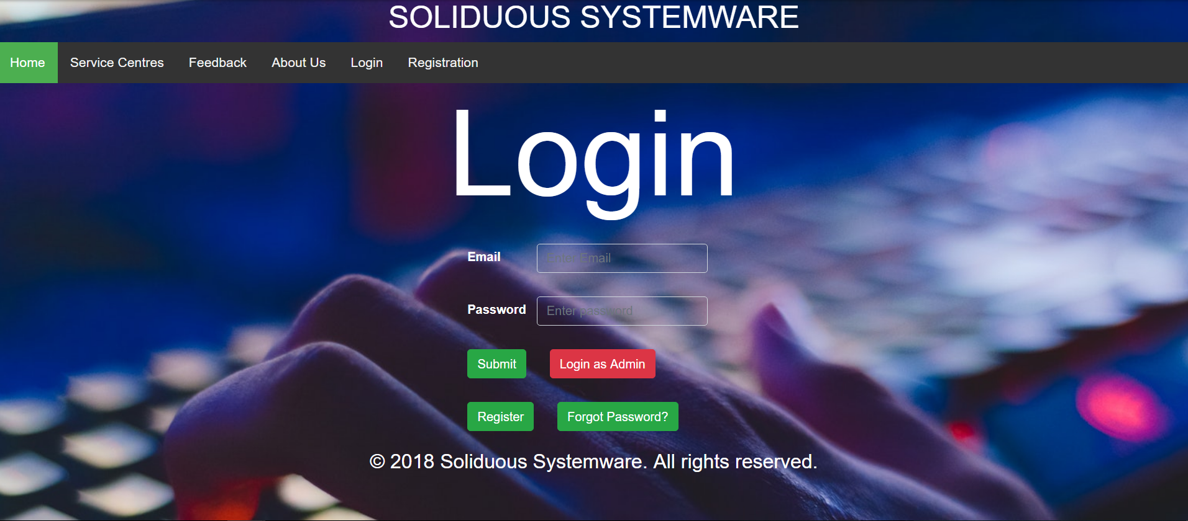

HomePage:

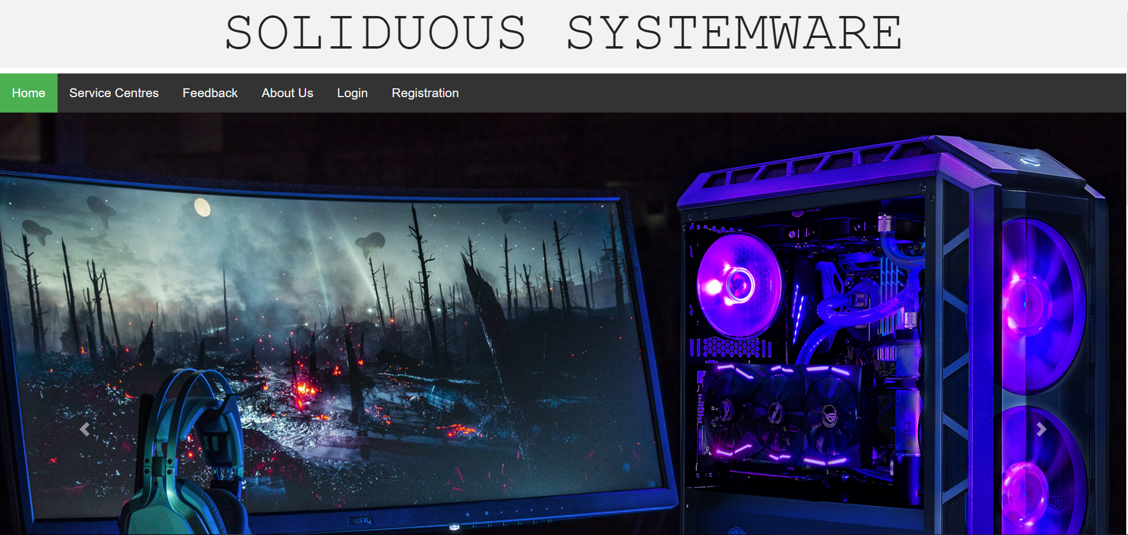

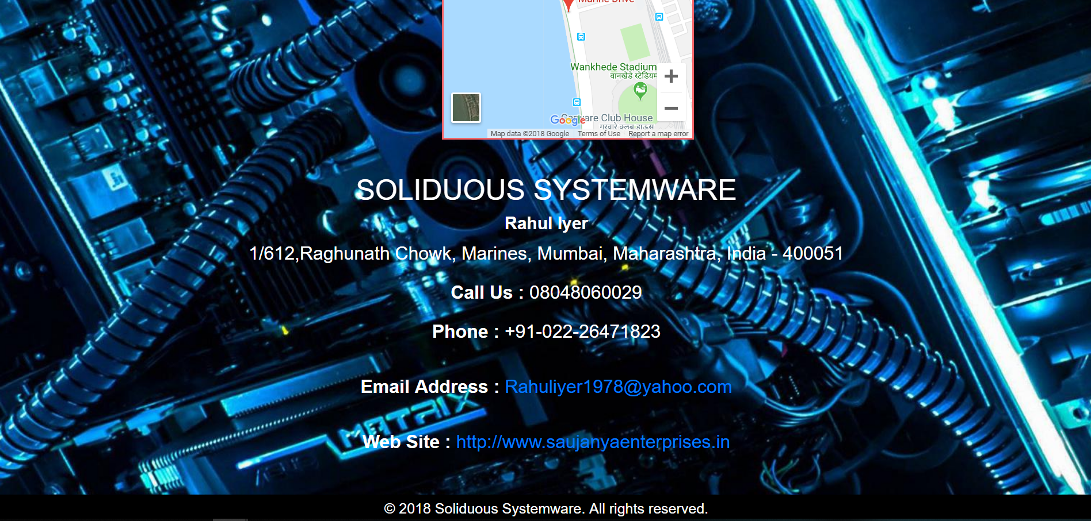

About Us:

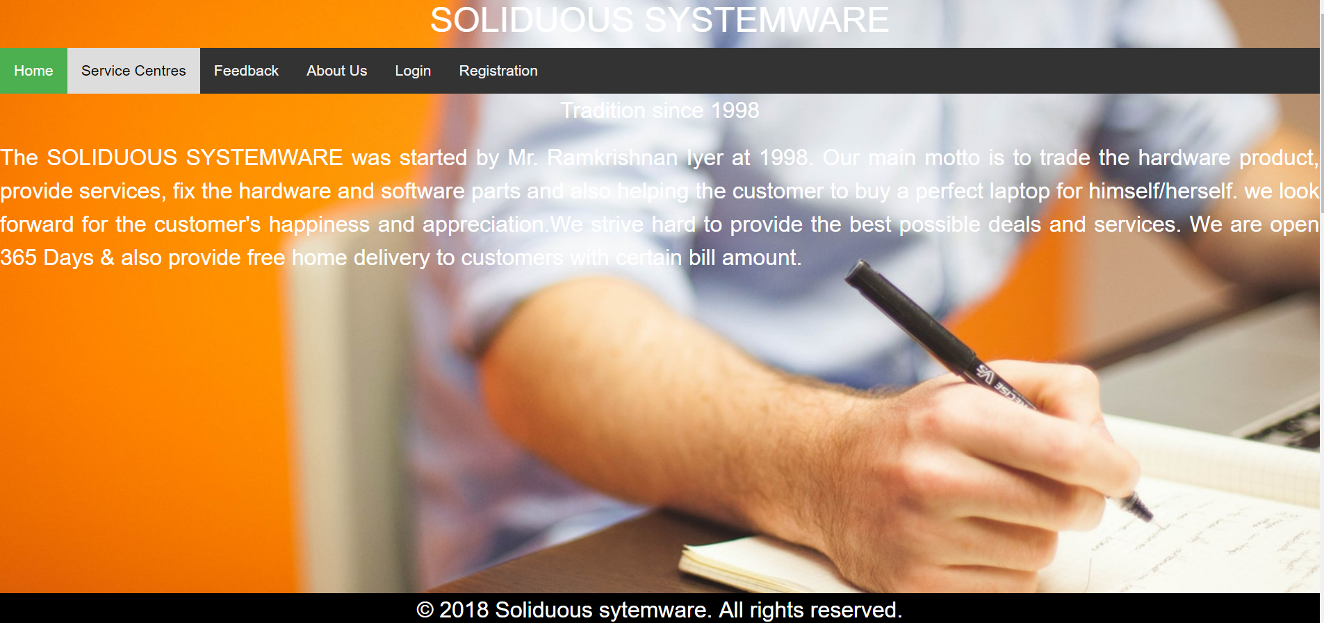

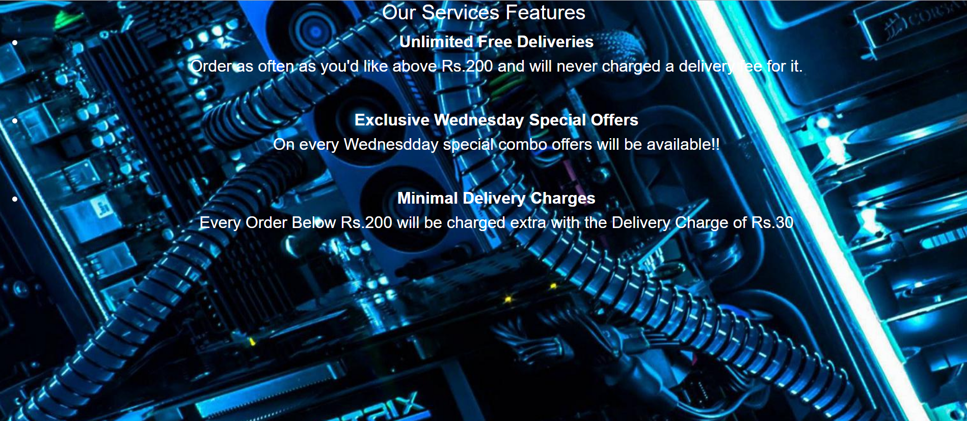

Feedback Page:

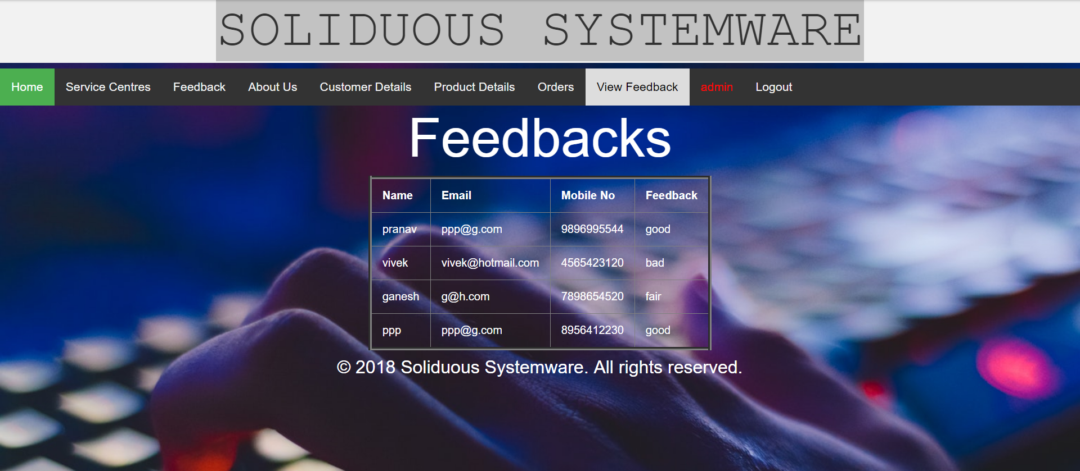

Product Insert Update Delete;

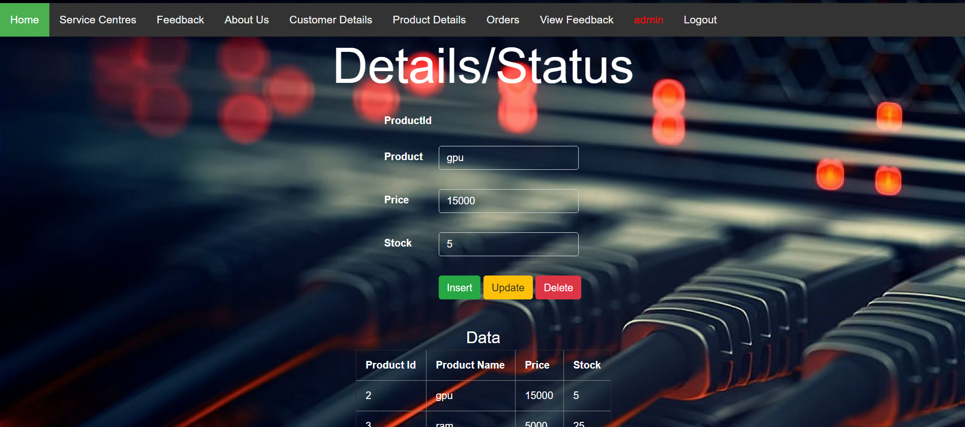

**CONCLUSION**

Through this project we took a step towards to minimize the gap between the traditional way and the online way using a common platform using php framework for development purpose. The present study contributes to the understanding of the effectiveness of online technical discussion forum in student improving their knowledge. Here we provide the best way of learning the software like PHP, HTML, Bootstrap, Javascript etc.We extend the current topics of discussion that use of multiple environment and improve the learning facilities. Education discussion forum has positive effect on student interest and interaction also learning,when fill bore with the traditional classroom lecture. By applying this the future scope will also increase like distance learning and professionals of work.

**ACKNOWLEDGEMENT**

The work has successfully completed with the contribution of all the people. It gives me immense pleasure to give my heartily welcome to various people directly or indirectly related to my present project work. We sincerely believe that I was not enough to have come across a group of human whose mere mode of living can inspire some one to work.My project guide Dr. Vijay Katkar ,Assoc. Prof in Department of Information Technology Engineering. He not only encouraged me to pursue my work but also initiated the self-belief and confidences, which helps me to take on various trivial, serious and inevitable hassles of life.